
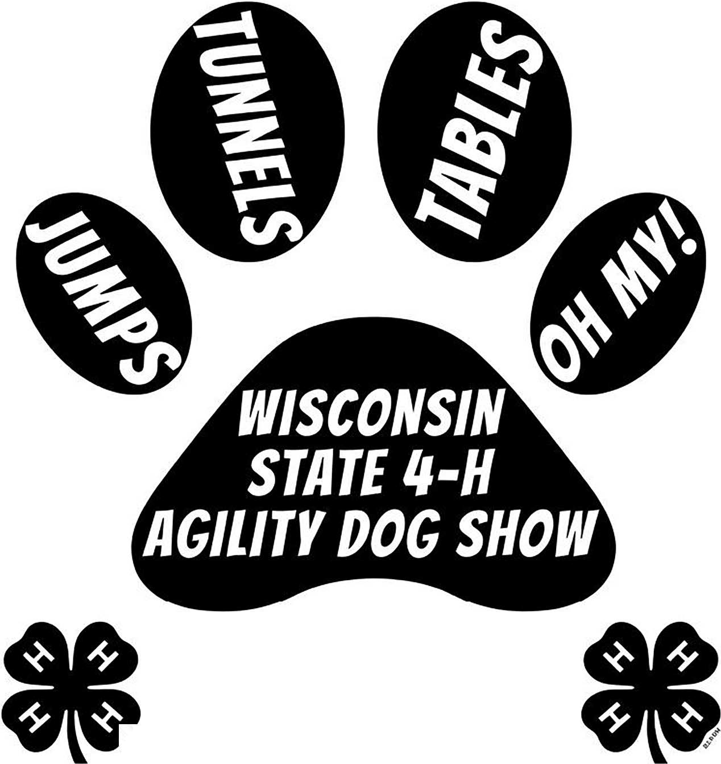

OCTOBER 10, 2026

/ SPRING VALLEY, WI

General Agility Dog Show Information 3
Schedule of Events 4
How to Enter & Entry Fees 4
Lodging in and near Spring Valley 5
State Dog Show Apparel Order Information 6
Agility Entry Form pg. 1 7
Agility Entry Form pg.2 8
WI State Dog Show Sponsorship Form 9-10
Raffle Basket, Class & Sponsorship 9-10
2026 Wisconsin State 4-H Dog Show County Summary Form 11

General Agility Dog Show Information

2026 State Dog Show Host Information
Questions should be directed to:

Co-Chair Show & Registration Chair
Sandy Miller 715-233-3074
Co-Chair Show & Registration Chair
Barb Viner 715-309-3116

Emergency Services for Sheriff, Fire & Ambulance: Dial 911
For non-emergency Services - call 715-778-5678

Deadlines/Important Dates

Entries Postmarked: September 1, 2026 NO LATE ENTRIES WILL BE ACCEPTED

October 10, 2026
Wisconsin 4-H Dog Agility Show
Overdale Canine Sports S1000 Westland Drive Spring Valley WI 54767

Welcome bags, clothing orders, and armband numbers should be picked up at the registration table when you check in for the show.

Kenneling space is limited. Please consider kenneling from your car.

Thank you for your participation in the 2026 WI State Agility Dog Show hosted by Wisconsin State 4-H Dog Association.
Wishing everyone safe travels to and from Dunn County 4H Dog Project!

Food: There will be food available for purchase on site. by the Dunn County 4H Dog Project

Pet Emergency please call : Allied Veterinary Emergency 715-529-5900 - 2809 Golf Road, Eau Claire WI 54701 alliedervet.com

Clean Up: If your dog messes you are responsible for your own clean up. Please bring your own clean up equipment.

POOP SCOOP RAFFLE SATURDAY! Drawing will be held at 1:00 pm - you must be present to win.

Schedule of Events

Saturday, October 10th, 2026: Agility Dog Show

8:00am Registration Table Open
8:45am Opening Ceremonies
9:00am Agility Judging Begins
  - All classes will be held indoors.
  - Classes will show in this order:
    - Standard Tunnelers
    - Advanced Tunnelers
    - JTT
    - Advanced Jumpers
    - Standard Agility
    - Advanced Standard

About 12:00 pm Lunch break and Poop Raffle Drawing

Registration

How to Enter & Entry Fees

- 4-H members need to complete the appropriate entry forms found at the back of this book and submit to their county leader with their fees by their county deadline.
- The designated county leader will also complete the county summary form at the end of the book and mail it with all county entries.
- Vaccination papers should be sent in with registration forms. A scan or photo of the vaccination certificate is acceptable. The leader who makes the entries for the county serves as verification that the vaccination certificates are up-to-date and that dogs/handlers have exhibited acceptable behavior.
- All entries from a county shall be submitted in one county mailing packet. Payment should be made with one check from the county. Checks must be postmarked on or before September 1st make checks payable to Wisconsin State 4-H Dog Project Association and sent to:
WI 4-H
UW Madison Division of Extension State 4-H Dog Agility Show
3500 University Ave
Madison WI 53705

Amount Description
$15 Standard Tunnelers and Advanced Tunnelers Class (per entry)
$15 JTT and Advanced Jumpers Class (per entry)
$15 Standard and Advanced Standard Class (per entry)

Lodging near Spring Valley, WI

HOTEL INFORMATION:
- The following area hotels accept well-behaved people and their pets.
- Exhibitors must contact hotels directly and identify themselves as having dogs. Some of these hotels do charge an extra fee for dogs.
- Be sure to verify the dog policy with the hotel of your choice when you make your reservation.
- Please be a responsible owner and a considerate hotel guest by maintaining a restful atmosphere and cleaning up after your dog.

AmericInn Hotel & Suites: 500 Baldwin Plaza Dr. Baldwin, WI 54002, (715)684-5888 call direct ask for WI Agility Dog Show $114/ night plus tax. asks about dog fee.

Baymont: 2110 10th ave Baldwin, WI 54002 (866)306-0941, Pet Fee: $30.00 per night/per pet

Super 8: 1622 north Broadway, Menomonie, WI 54751 (715)235-8889. Block held under 2026 WI 4h Dog agility.

AmericInn: 1915 North Broadway Menomonie, WI 54751, (715) 235-4800

Camping: Highland Ridge, Eau Galle Lake, Recreation.gov, 715-778-5562

State Agility Clothing Order
Due August 10th through the online form
Online order form:
https://forms.gle/3UG2VQkLHf1NR2zq5

Reminder: If orders are not placed through the online order form by August 10th, they will not be able to be placed later.
Directions:
- Complete this online form no later than August 10th.
- One form per person/family please.
- Include this information sent on the form with the county packet. This includes the county summary page.
Payments: Send payments with a copy of form, in with the county packet.
If you have any questions, please email Alycia Kringel at Alyciakringel16oz4h@gmail.com

Agility Entry Form Pg.1
ENTRY DEADLINE: September 1st, 2026
Exhibitor's Name Age Grade (as of January 2026):________ Address:_________________________________
City Zip County Phone Number Email:
Dog #1
Dog's Call Name Age Sex: Breed (if mixed write what is listed on vaccination papers): _ 1st Option: Teams may enter into JTT, Standard agility and Standard Tunnelers

Class 1: Standard Tunnelers
Class A is 1 year ONLY if child AND/OR
dog have never competed at the State
st

On Leash Height: 4" _ 8" _ | 12" _ | 16" _
Off Leash Height: 4" _ 8" _ | 12" _ | 16" _
Class 2: Jumps, Tunnels and Table (JTT)
Division A
On Leash Height: 4" _ 8" _ 12" _ 16" _
Agility Show. Or achieved a title at another venue. Refer to Page 5 in Agility
Guidelines
No Cross Entering between option 1 or 2

Class 3: Standard Agility
Division A No Weave poles

Off Leash Height: 4" _ 8" _ 12" _ 16" _

Division B
On Leash Height: 4" _ 8" _ 12" _ 16" _
On Leash Height: 4" _ 8" O_ ff Leash Height: 4" _ 8" _
Division B No Weave Poles
12" _ 16" _
12" _ 16" _

Off Leash Height: 4" _ 8" _ 12" _ 16" _
On Leash Height: 4" _ 8" _ 12" _ 16" _
Off Leash Height: 4" _ 8" _ 12" _ 16" _

2nd Option: Teams may enter into Advanced Jumpers, Advanced Standard and Advanced Tunnelers

Class 4: Advance Tunnelers (off leash) Class 5: Advanced Jumpers
Height: 4" 8" 12” 16” Height: 4" 8" 12” 16”

Class 6: Advanced Standard
Height: 4" 8" 12" 16"
Health Record (Date of Vaccinations: month, day, year) Rabies
A CURRENT COPY OF YOUR DOG'S RABIES CERTIFICATE AND VACCINATION RECORD MUST BE INCLUDED WITH YOUR FORMS
- I declare that all other vaccinations (DHL/PARVO/ etc.) have been given and are up to date.
- I declare that this 4-H member is currently enrolled in the 4-H Dog Project in our county, and that the above is correct

Youth Exhibitor Signature Parent/Guardian Signature Project Leader or County Agent
signature

Agility Entry Form Pg. 2
ENTRY DEADLINE: September 1st, 2026 Exhibitor's Name_____________________________________ Age Grade (as of January 2026):________ Address:______________________
City Zip County Phone Number Email:
Dog #2
Dog's Call Name Age Sex: Breed (if mixed write what is listed on vaccination papers): _ 1st Option: Teams may enter into JTT, Standard agility and Standard Tunnelers

Class 1: Standard Tunnelers

On Leash Height: 4" _ 8" _ | 12" _ | 16" _
Off Leash Height: 4" _ 8" _ | 12" _ | 16" _
Class 2: Jumps, Tunnels and Table (JTT)

Division A  On Leash Height: 4" _ | 8" _ | 12" _ | 16" _
Off Leash Height: 4" _ | 8" _ | 12" _ | 16" _
Division B  On Leash Height: 4" _ | 8" _ | 12" _ | 16" _
Off Leash Height: 4" _ | 8" _ | 12" _ | 16" _
Division A is 1st year ONLY if child AND/OR dog have never competed at the Agility. Or achieved a title at another venue. Refer to Page 5 in Agility Guidelines




No Cross Entering between option 1 or 2

Class 3: Standard Agility
Division A No Weave poles
On Leash Height: 4" _ 8" _ 12" _ 16" _
Off Leash Height: 4" _ 8" _ 12" _ 16" _
Division B No Weave poles
On Leash Height: 4" _ 8" _ 12" _ 16" _
Off Leash Height: 4" _ 8" _ 12" _ 16" _

2nd Option: Teams may enter into Advanced Jumpers, Advanced Standard and Advanced Tunnelers

Class 4: Advance Tunnelers (off leash) Class 5: Advanced Jumpers
Height: 4" 8" 12” 16” Height: 4" 8" 12” 16”

Class 6: Advanced Standard
Height: 4" 8" 12" 16"

Health Record (Date of Vaccinations: month, day, year) Rabies A CURRENT COPY OF YOUR DOG'S RABIES CERTIFICATE AND VACCINATION RECORD MUST BE INCLUDED WITH YOUR FORMS
- I declare that all other vaccinations (DHL/PARVO/ etc.) have been given and are up to date.
- I declare that this 4-H member is currently enrolled in the 4-H Dog Project in our county, and that the above is correct

Youth Exhibitor Signature Parent/Guardian Signature Project Leader or County Agent

SPONSORSHIIP & FUNDRAISING

With the formation of the Wisconsin State 4-H Dog Association Committee and Board, it is our goal to have the Statewide Project host the State 4-H Obedience and Agility shows in the future. This will take the pressure off any one county to host these events, and it will also help insure we have a show each year. We realize that it takes a lot of time, commitment, and funds to host these shows and that not every county has the manpower or facility to do so. Recent years have shown us that formation of this committee is paramount for the success of the State Dog shows as well as future Dog Project workshops and clinics for our continued education.

As we look to the future, these shows will eventually be moving around the state to different locations. As we get closer to that goal, we will need to be looking at purchasing our own equipment - trailer, matting, ring gates and jumps, just to name a few items. Having this equipment at our disposal means that we do not have to rely on outside sources to provide mats, ring gates and jumps for our state shows.

We are asking for everyone's assistance in the pursuit of these goals. We would like each county to assist in getting sponsorships for the shows. If every county could help get a couple of sponsorships to offset the cost of facility rental, judges, awards, scoresheets, and food for the judges and ring stewards and other miscellaneous expenses, it would go a long way in securing the funds to meet our long-term goals.

A fundraising letter is on the following page. Would you please consider helping the State 4H Dog Project Committee in our fundraising efforts? Anyone can donate. How about asking an alumni, your county club or project, your vet, dog kennel, pet store that you frequent, a local kennel club or even parents and grandparents? No amount is too large or too small and everything received will help offset the expenses of the show.

Raffle Baskets

Believe it or not, the raffle baskets are a tremendous fundraiser at the shows and have the potential bringing in over $1,000 for the project!! We would like to ask each county to put together a raffle basket for the show. Baskets do not have to be dog-related - they can be anything really (no alcohol please). Baskets can be dog-related...toys, treats, training equipment, human food/snack related, candles, lotions, clothing - use your imagination and make it fun. Have your project members bring items for your basket.

County Registration Fee

There will be a county registration fee this year. This is the same that the State 4-H Horse Association has when sending members to the State 4-H Horse show each year. These funds will be used to also offset the costs of putting on the show. Often, a county's Leaders Associations will agree to help pay these fees.

The registration fees are as follows:
For counties sending 1 to 10 members to State - $50.00
For counties sending 11 or more members to State - $100.00

Wisconsin 4-H Dog Association
Each year 4-H Dog Project volunteer leaders and parents work together with 4-H project members to train their dogs to be better companions. Members are trained in obedience, showmanship, rally and agility. They also attend workshops and are given lessons in grooming and general care of their dogs. Leaders throughout the state in the 4-H Dog project take a great deal of pride in their project member's achievements, not only on the individual level, but also on the statewide level.

We are very pleased to announce that the Wisconsin State 4-H Dog Project has now formed a committee complete with a Board of Directors. This board will now oversee the two State 4-H Dog Shows - Obedience, Rally and Showmanship - as well as the Agility show. With the Wisconsin State 4-H Dog Project Association now overseeing these shows, our goal is to ensure that they will be held each year. This also relieves the burden from our individual counties of trying to host the shows, especially if they do not have the manpower, resources or facility to do so.

We will also be offering educational experiences and workshops for not only our youth, but also our leaders. It is our hope to offer workshops in Advanced Obedience training techniques, Agility, Showmanship as well as introducing different types of areas our youth can train and compete in, such as scent work. We feel that hosting these shows as well as the workshops and clinics are a very fundamental part of providing a positive 4-H experience for our youth.

Our Obedience & Showmanship Show will be held in Jefferson, WI on September 27 & 28, 2026 and our Agility show will be held in Spring Valley on October 10, 2026. We are planning on hosting an educational workshop in October 2026

The Wisconsin State 4-H Dog Project Association is asking for your help with sponsoring these two shows. Your generous donation will be tax deductible, and you will be helping the Association achieve their goal of putting on fantastic shows for our youth.

2026 Wisconsin State 4-H Dog Shows Donation Opportunities

Class Sponsorship (Full Class) - $100

Class Sponsorship (Half Class) - $ 50
Hospitality Donation for Exhibitor's Bags (Please plan on 350 bags between the 2 shows)

Cash Donation for show $ (any amount)
Name: Phone:
Address:

County Requesting Sponsorship

10

2026 Wisconsin State 4-H Dog Show County Summary Form

ENTRY DEADLINE: September 1st, 2025 ****Save this form for reference
Contact Person: County: Email: Address: City: Zip: Number of leaders attending:___
All clothing orders needed to be pre-ordered online by Aug 10th
Exhibitor Name | Standard Tunnelers | JTT | Standard Agility | Advanced Jumpers | Advanced Standard | Advanced Tunnelers | T-Shirt | Long sleeve  T-Shirt | Hooded Sweatshirt | Crewneck Sweatshirt | Quarter Zip | Quarter Zip w/ pocket | Sweatpant | Total
 | $15 | $15 | $15 | $15 | $15 | $15 | $14-17 | $16-19 | $33-36 | $18 -21 | $36-39 | $58-61 | $26-29
County Registration Fee | 1-10 exhibitors $50 11 exhibitors or more $100
Sponsorships
Total for County |  |  |  |  |  |  |  |  |  |  |  |  |  | $

MAKE ONE CHECK PAYABLE TO: Wisconsin State 4-H Dog Project Association Send copy of paper entries to:
WI 4-H
UW Madison Division of Extension State 4-H Agility Dog Show
3500 University Ave
Madison WI 53705
Make copies of this sheet as needed and attach.

All entries from each county must be postmarked by September 1st. 2026. No late entries will be accepted. Refunds will only be refunded for late entries. In that case, your entry and money will be returned. PLEASE KEEP A COPY OF THIS ENTRY BLANK.
11

