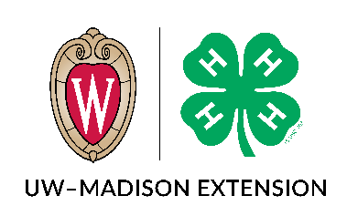 | James W. Crowley Leadership Award  Essay Questions
***This document is intended for planning purposes only. You must include your essay responses in the full online application form found on the 4-H Website: https://4h.extension.wisc.edu/opportunities/projects/large-animals/dairy-project/james-w-crowley-dairy-leadership-award/ Please contact Amanda Lacey (amanda.lacey@wisc.edu or 608-262-1557) or Jill Jorgensen (jill.jorgensen@wisc.edu) with questions or if you need assistance in completing the application.
Name: |  | County:
Dairy Activities
Briefly explain the agreements on the animals in your dairy project. (i.e. Are they owned or managerial or both, are they part of your project on a yearly basis or some other longer-term arrangement?) 100 words or less.

What is your involvement in the daily care and management of your project animals? Please include where your project animals are housed (home farm, neighbor, relative, cooperating dairy, etc.) and your daily role on that farm. 200 words or less.

Briefly list your involvement in what you consider important dairy activities during the last three years only (dairy bowl, dairy judging, local fairs, breed shows, state fairs, demonstrations, promotional events, etc.) 250 words or less.

Leadership Experience
Describe your 4-H leadership experiences (i.e. project, club, county, district, state) including what you have done as a mentor to help younger 4-H members. 250 words or less.

Describe any other leadership experiences (i.e. through FFA, school, community groups, etc.). 250 words or less.

What have you learned from your leadership and mentorship experiences? 250 words or less.

Letter of Recommendation (1 letter) from a 4-H Dairy Project Leader or County Positive Youth Development Staff Recommendation:
Please ask your Dairy Project Leader or your County Positive Youth Development staff person to submit a letter stating why this member should be considered for a 2025 Wisconsin 4-H James W. Crowley Dairy Leadership award

Letters can be emailed to amanda.lacey@wisc.edu or mailed to
Crowley Award/Wisconsin 4-H
432 N. Lake St., Rm 103
Madison, WI 53706

