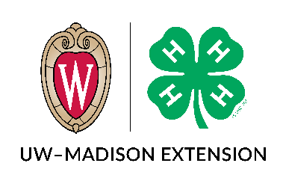 | James W. Crowley Leadership Award  Essay Questions
***This document is intended for planning purposes only. You must include your essay responses in the full online application form found on the 4-H Website: https://4h.extension.wisc.edu/opportunities/projects/large-animals/dairy-project/james-w-crowley-dairy-leadership-award/ Please contact Amanda Kadlecek (amanda.kadlecek@wisc.edu or 608-262-1557) or Jill Jorgensen (jill.jorgensen@wisc.edu) with questions or if you need assistance in completing the application.
Name: |  | County:
Dairy Activities
Briefly list your involvement in what you consider important dairy activities during the last three years only (dairy bowl, dairy judging, local fairs, breed shows, state fairs, demonstrations, promotional events, etc.) 250 words or less.

Leadership Experience
Describe your 4-H leadership experiences (i.e. project, club, county, district, state) including what you have done as a mentor to help younger 4-H members. 250 words or less.

Describe any other leadership experiences (i.e. through FFA, school, community groups, etc.). 250 words or less.

What have you learned from your leadership and mentorship experiences? 250 words or less.

An important role for all who work in the dairy industry is to serve as ambassadors for our industry and educate the public about the nutrition of the milk our cows produce and general farm practices. Give an example of a time where you were able to educate the public or a group of peers about the benefits of consuming dairy products and/or how you care for your animals. 200 words.

4-H Dairy Project Leader or County Positive Youth Development Staff Recommendation:
Please ask your Dairy Project Leader or your county’s PYD staff person to submit a letter stating why this member should be considered for a Wisconsin James W. Crowley Dairy Leadership award.
Letters can be emailed to amanda.kadlecek@wisc.edu or mailed to
Crowley Award/Wisconsin 4-H
432 N. Lake St., Rm 103
Madison, WI 53706

