2022-2023 Wisconsin 4-H Leadership Council Application

Information: Electronic file found at https://4h.extension.wisc.edu/opportunities/statewide-events-and-opportunities/wisconsin-4-h-leadership-council/

Purpose of the Wisconsin 4-H Leadership Council:
- advocate for Wisconsin 4-H
- provide input into enhancing the Wisconsin 4-H Program
- model youth and adult partnerships
- provide education and leadership opportunities for others
- engage youth and adult volunteers in statewide leadership roles

Required of Wisconsin 4-H Leadership Council Members:
- Attend and participate in Wisconsin 4-H Leadership Council Meetings:
Virtual Orientation: December 2022; Winter Retreat: Friday, January 27-Sunday, January 29, 2023; Spring Planning Meeting: Friday, April 14-Sunday, April 16, 2023; 2023 Fall Forum and additional planning meetings
- Contribute to statewide events, including but not limited to Pathways Conference - June 2023, Governor’s Blue Ribbon Meat Products Auction at the Wisconsin State Fair - August 2023, Fall Forum, and Wisconsin 4-H Foundation Fundraisers.
- Fulfill committee work, promote Wisconsin 4-H Youth Development, communicate with and present to counties in your region and other agreed upon responsibilities
- Communicate regularly with Wisconsin 4-H Leadership Council advisors and members.
- Conduct yourself, at all times, in a manner that is consistent with Extension and
4-H Youth Development Behavior Expectations.

Demonstrated Skills and Expectations of Wisconsin 4-H Leadership Council Members:
- Leadership in 4-H Programs
- Teamwork and Cooperation
- Verbal and Written Communication Skills
- Public Relations Skills
- Responsibility
- Positive Role Model
- Positive Attitude
- Ability to Work in Unusual or Unexpected Situations (Adaptable and Flexible)
- Accepting of Differences in Others

Cost:
The majority of Leadership Council expenses are covered by the Wisconsin 4-H Foundation and Wisconsin 4-H Youth Development. Council members are responsible for registration fees for Fall Forum; meals at training events, as well as other supplies such as t-shirts; transportation to workshops and trainings; and apparel costs. Support for costs may be available from your county leaders’ association or other sources. Cost should not be a barrier for application.

Questions: Feel free to reach out to Carlea Liermann at carlea.liermann@wisc.edu or Laura Huber at laura.huber@wisc.edu with any questions regarding WLC and/or the application process.
Wisconsin 4-H Leadership Council Eligibility:
Youth:
- 4-H youth member in good standing and in 9th through 11th grade at time of election
- Support from your county 4-H Youth Development Staff/Educator to serve on a statewide council
- Experience working with youth in leadership roles
- Willingness to serve on committees and work with adult volunteers
- Agree to abide by Youth Behavior Expectations

Adults:
- Enrolled, certified 4-H volunteer leader
- Support from your county 4-H Youth Development Staff/Educator to serve on a statewide council
- Experience working with youth in leadership roles
- Willingness to serve on committees and work with youth leaders
- Agree to abide by Volunteer Behavior Expectations
WI 4-H Leadership Council Member Election Process:

Youth: The number of representatives per region (East Metro, North, or South) is determined by size of 4-H membership in each region with a minimum of 3 representatives per region.
Adults: Three representatives per region (East Metro, North, South).

The completed Wisconsin 4-H Leadership Council Application, cover letter and résumé must be received by the State 4-H Office no later than 4 pm on October 14, 2022. While electronic files are preferred, paper applications will also be accepted. Email applications to lpine@wisc.edu or mail to WI 4-H; Attention: Laura Pine; 432 N. Lake St., Room 103, Madison, WI 53706.
- Applicants need to allow time for their Staff/Educator and another volunteer leader to provide a recommendation. References must be sent directly to lpine@wisc.edu and arrive no later than 4 pm on October 14, 2022. If your county has 4-H Staff/Educator vacancies, you may have an adult 4-H leader, not related to you, complete the reference.
- Current officers and advisors of the WI 4-H Leadership Council will review applications and invite applicants to a Zoom Interview with WLC Members. Candidates will be notified by October 21, 2022 and interviews will be held October 24-28 based off of candidate availability listed in application. The final slate of candidates will be notified by October 28. These dates are tentative and flexibility is needed with this changing process.
- The election will be by caucus. All WI 4-H youth members and leaders will have the opportunity to vote for regional representation via Google Form Sunday, November 6^{h} at Fall Forum. There will be an aggregated point system that will be calculated by county; all votes will be counted towards counties official candidate vote. Candidate Résumés will be shared on the Election Website with Recorded Candidate Introductions and Speeches.
- Newly elected Council members will be announced at and will take office immediately.

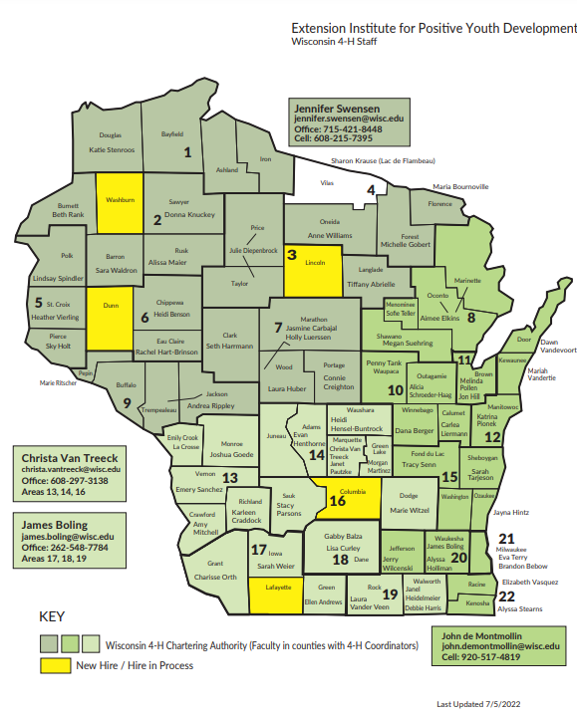

TIMELINE
- Application, Resume and Cover Letter Due – October 14, 2022 at 4pm
Email to lpine@wisc.edu, or mail to Attention: Laura Pine, 4-H Youth Development, 432 N. Lake St., Madison, WI 53703. Electronic documents preferred. An email confirmation will be sent upon receiving application materials.
- References Due – October 14, 2022
- Review of Applicants – October 16 - 21, 2022
- Candidates Notified by October 21, 2022
- Candidate Interviews with WLC Members – October 24 - 28, 2022
- Notification of Final Slate of Candidates – October 28, 2022
- Election – Sunday, November 6th
Wisconsin 4-H Leadership Council Meetings
Council members are expected to attend and participate in:
- Virtual Council Orientation – December 2022
- Winter Retreat – January 2023
- Spring Planning Meeting – April 2023
- Pathways Conference – June 2023 (Depending on responsibilities,
only some adults will attend the whole conference, all youth will attend the entire conference and pre-conference prep; business meeting may be held for all members in the days prior.)
- Fall Forum – November 2023
Council members also participate in other statewide events, including but not limited to the Governor’s Meat Products Auction at the Wisconsin State Fair, the Wisconsin Farm Bureau Annual Meeting, and other Wisconsin 4-H Foundation fundraisers and events.
Applicant Checklist:
- Submit the following items no later than October 14, 2022
- Cover Letter
- Resumé (No more than 2 pages; see sample at https://4h.extension.wisc.edu/opportunities/statewide-events-and-opportunities/wisconsin-4-h-leadership-council/)
- 2-page Offical WLC Application
- References from county staff and another leader/mentor/teacher due to lpine@wisc.edu
Address Questions to Carlea Liermann(carlea.liermann@wisc.edu)
Laura Huber (laura.huber@wisc.edu)

2022-2023 WISCONSIN 4-H LEADERSHIP COUNCIL (WLC)
OFFICIAL APPLICATION

Please submit this application with a cover letter and no more than a 2-page resume of your 4-H, school/work and community leadership experiences. Sample resumes and cover letters can be found at: https://4h.extension.wisc.edu/opportunities/statewide-events-and-opportunities/wisconsin-4-h-leadership-council/

Personal Information

Legal Name County_____________________
(first) (middle initial) (last)

Preferred Name:___________________________________________________________________________

Home Address: __________________________________________________________________________

City __________________________________________Zip Code ________ Gender: ____________________

Primary Phone (_____ )__________________________ Secondary Phone (______)_____________________
(Check: £ cell £ landline) (Check: £ cell £ landline)
E-mail ________________________________________

Youth ______ Year in School as of September 1, 2022________ Years in 4-H ________
Parent/Guardian Name ________________________________________________________________

Address/Telephone ___________________________________________________________________

Adult ______ Years as a 4-H Adult Leader _______

Please circle the days and times you’re available for a 15 minute interview with WLC Leadership:

October 24 5pm 6pm 7pm 8pm
October 25 5pm 6pm 7pm 8pm
October 26 5pm 6pm 7pm 8pm
October 27 5pm 6pm 7pm 8pm

Please answer the following questions IN THE SPACE PROVIDED only. The most helpful responses will include specific details about your role, activities and learning from the experience. FONT SIZE to be used is 10-12. Do not add pages or write on the back of any pages or change this form. If guidelines are not followed, points will be deducted.

- What are your TWO (2) strongest skills/traits that you would bring to WLC? How would these two skills/traits help achieve the goals and purposes of WLC?

- Describe ONE (1) experience you have had working with youth and adult partnerships in any group (examples of groups: 4-H, school, church, community, or other youth groups). Explain in detail. What were your specific roles and how did the partnership work?

- Give an example, from something that has happened within the past TWO (2) years, where you helped to develop leadership in others. Explain in detail how you specifically helped to develop their leadership; what things did you do or not do to ensure they had an opportunity to grow?

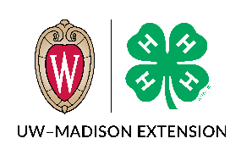
Submit No Later Than October 14, 2022 to:
lpine@wisc.edu or mail to Attention: Laura Pine, 4-H Youth
Development, 432 N. Lake St, Madison, WI 53706
Electronic Documents Preferred
The University of Wisconsin-Extension provides affirmative action and equal opportunity in education, programming and employment for all qualified persons regardless of race, color, gender/sex, creed, disability, religion, national origin, ancestry, age, sexual orientation, pregnancy, or parental, arrest or conviction record or veteran status.

La Universidad de Wisconsin-Extensión proporciona acción afirmativa e igualdad de oportunidades en educación, programas y empleo, para todas las personas calificadas, sin tener en cuenta raza, color, sexo, credo, discapacidad, religión, nacionalidad de origen, ascendencia, edad, orientación sexual, gravidez o paternidad, historial de detención o condena o estado de veterano de guerra.
WISCONSIN 4-H LEADERSHIP COUNCIL
CONFIDENTIAL 4-H Youth Development Staff/Educator Reference
(If county position is vacant, other Volunteer not related to Applicant)
Applicant's Name _____________________________ County ___________________________
How long have you known this applicant and in what capacity? ______________________________
The above named individual has applied to be a Wisconsin 4-H Leadership Council member. Your thoughtful evaluation of the applicant's ability to participate as a responsible delegate is appreciated. Candidates are selected by the Wisconsin 4-H Leadership Council officers and advisors. All information is confidential.
1. Interpersonal Relations: As you observe this applicant in relationships with others, is the applicant usually:
Comments
Cooperative ___ yes ___no _______________________________
Looked to for Guidance ___ yes ___no _______________________________
Respected ___ yes ___no _______________________________
Willing to Try New Things ___ yes ___no _______________________________
Inclusive ___ yes ___no _______________________________
Sensitive Toward Others ___ yes ___no _______________________________
Experience in Youth/Adult Partnerships ___ yes ___no _______________________________

2. In comparison with persons you have known, how would you rate the applicant in the following areas?
 | Below Average | Average | Above Average | Top 10%
Public Speaking | _____ | _____ | _____ | _____
Leadership | _____ | _____ | _____ | _____
Role Model | _____ | _____ | _____ | _____
Responsibility | _____ | _____ | _____ | _____
Positive Attitude | _____ | _____ | _____ | _____
Teamwork | _____ | _____ | _____ | _____
Dependable | _____ | _____ | _____ | _____

3. Do you recommend this applicant? ___ yes ___no Why or why not?

Please review the information sheet on the Wisconsin 4-H Leadership Council and comment on this candidate’s strengths and limitations for this role below.

Date ____________________ Agent/Educator Name______________________________________
Signature (or Type Name)

Submit No Later Than October 14, 2022 to:
lpine@wisc.edu or mail to Attention: Laura Pine, 4-H Youth
Development, 432 N. Lake St, Madison, WI 53706
Electronic Documents Preferred
The University of Wisconsin-Extension provides affirmative action and equal opportunity in education, programming and employment for all qualified persons regardless of race, color, gender/sex, creed, disability, religion, national origin, ancestry, age, sexual orientation, pregnancy, or parental, arrest or conviction record or veteran status.

La Universidad de Wisconsin-Extensión proporciona acción afirmativa e igualdad de oportunidades en educación, programas y empleo, para todas las personas calificadas, sin tener en cuenta raza, color, sexo, credo, discapacidad, religión, nacionalidad de origen, ascendencia, edad, orientación sexual, gravidez o paternidad, historial de detención o condena o estado de veterano de guerra.

WISCONSIN 4-H LEADERSHIP COUNCIL
CONFIDENTIAL Reference
(Mentor, Leader, Volunteer not related to Applicant)
Applicant's Name _____________________________ County ___________________________
How long have you known this applicant and in what capacity? ______________________________
The above named individual has applied to be a Wisconsin 4-H Leadership Council member. Your thoughtful evaluation of the applicant's ability to participate as a responsible delegate is appreciated. Candidates are selected by the Wisconsin 4-H Leadership Council officers and advisors. All information is confidential.
1. Interpersonal Relations: As you observe this applicant in relationships with others, is the applicant usually:
Comments
Cooperative ___ yes ___no _______________________________
Looked to for Guidance ___ yes ___no _______________________________
Respected ___ yes ___no _______________________________
Willing to Try New Things ___ yes ___no _______________________________
Inclusive ___ yes ___no _______________________________
Sensitive Toward Others ___ yes ___no _______________________________
Experienced in Youth/Adult Partnerships ___ yes ___no _______________________________

2. In comparison with persons you have known, how would you rate the applicant in the following areas?
 | Below Average | Average | Above Average | Top 10%
Public Speaking | _____ | _____ | _____ | _____
Leadership | _____ | _____ | _____ | _____
Role Model | _____ | _____ | _____ | _____
Responsibility | _____ | _____ | _____ | _____
Positive Attitude | _____ | _____ | _____ | _____
Teamwork | _____ | _____ | _____ | _____
Dependable | _____ | _____ | _____ | _____

3. Do you recommend this applicant? ___ yes ___no Why or why not?

Please review the information sheet on the Wisconsin 4-H Leadership Council and comment on this candidate’s strengths and limitations for this role below.

Date ____________________ Name______________________________________
Signature (or Type Name)

Submit No Later Than October 14, 2021 to:
lpine@wisc.edu or mail to Attention: Laura Pine, 4-H Youth
Development, 432 N. Lake St., Madison, WI 53706
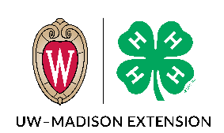
Electronic Documents
Wisconsin Leadership Council Assessment Form
The University of Wisconsin-Extension provides affirmative action and equal opportunity in education, programming and employment for all qualified persons regardless of race, color, gender/sex, creed, disability, religion, national origin, ancestry, age, sexual orientation, pregnancy, or parental, arrest or conviction record or veteran status.

La Universidad de Wisconsin-Extensión proporciona acción afirmativa e igualdad de oportunidades en educación, programas y empleo, para todas las personas calificadas, sin tener en cuenta raza, color, sexo, credo, discapacidad, religión, nacionalidad de origen, ascendencia, edad, orientación sexual, gravidez o paternidad, historial de detención o condena o estado de veterano de guerra.
***NOTE: This example form will be used to review your application. It is for your reference only and does not have to be filled out when you apply.***
Applicant Name: | Info not provided by the applicant | Appears to be less than  qualified | Appears to be somewhat qualified | Appears to be acceptably qualified | Appears to be highly qualified
Minimum Qualifications Required
Submitted required information
- Resume – 1 page suggested
- 2 page application
- Reference
Enrolled 4-H member in 9th – 11th grade –or-
Enrolled certified 4-H volunteer leader
Demonstrated leadership in local and county programs
Experience working in youth adult partnerships
Depth of experience with verbal and written communication skills
Demonstrated experience on committees
Additional Skills and Experiences

Demonstrated leadership at state level
Experience speaking with stakeholders
Experience teaching and facilitating workshops for youth and adults
Strengths:

Limitations:

